

**<<Project name>>**

**Software Requirement Specification**

– Can Tho, Januar 2021 –

**Table of Contents**

I. Overview 3

1. Introduction 3

2. System Functions 4

3. Common Requirements 7

II. Functional Requirements 9

1. <<Feature Name 1>> 9

a. <<Function Name 1>> 9

b. <<Function Name 2>> 9

2. <<Feature Name 2>> 9

Figure 1. Hình mô tả.... 6

# I. Overview

## 1. Introduction

Currently, vehicles are more and more participating in traffic, the form of vehicle management at traditional parking lots has not met the needs of people because manual management takes a lot of time, not to mention hours. Peak time when the number of cars in and out of the parking lot is very crowded. So, with parking management software, we can solve these problems. The software allows to store and manage information about vehicles and customers more easily, helping us to manage parking more efficiently.

## 2. System Function

#### a. Screen Flow

*[This part shows the system screens and the relationship among screens. You can draw the Screens Flow for the system in the form of diagram as below]*

I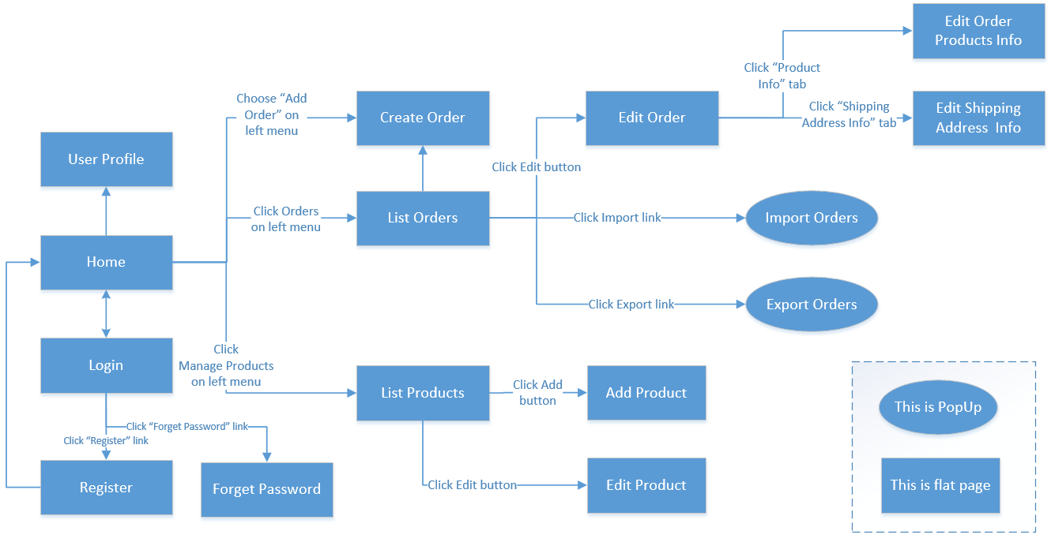

Figure . Hình mô tả....

#### b. Screen Details

*[Provide the descriptions for the screens in the Screens Flow above]*

|  |  |  |  |
| --- | --- | --- | --- |
| **#** | **Feature** | **Screen** | **Description** |
| 1 | Order Meals | Create Order | <<Screen Brief description>> |
| 2 | Order Meals | Change Order |  |
| 3 | .. |  |  |

#### c. User Authorization

*[Provide the system roles authorization to the system features (down to screens, and event to the screen activities if applicable) in the table form as below – replace Role1, Role2,… with the specific system user role names]*

|  |  |  |  |  |  |
| --- | --- | --- | --- | --- | --- |
| **Screen** | **Role1** | **Role2** | **Role3** | **Role4** | **RoleX** |
| <<Screen Name1>> | X |  |  | X | X |
| <<Screen Activity>> |  |  |  | X | X |
| <<Screen Name2>> | X |  |  | X |  |
| Query All Data | X |  |  |  |  |
| Query Own Data |  |  |  | X |  |
| Query Managed Data |  |  |  | X |  |
| Add New Data |  |  |  | X | X |
| Update All Data |  |  |  |  | X |
| Update Own Data |  |  |  |  | X |
| Update Managed Data |  |  |  |  | X |
| Delete Data |  |  |  |  |  |
| … |  |  |  |  |  |

In which:

* Role1: <<role1 description>>
* Role2: <<role2 description>>
* …

#### d. Non-Screen Functions

*[Provide the descriptions for the non-screen system functions, i.e batch/cron job, service, API, etc.]*

|  |  |  |  |
| --- | --- | --- | --- |
| **#** | **Feature** | **System Function** | **Description** |
| 1 | <<Feature Name>> | <<Function Name1>> | <<Function Name1 Description>> |
| 2 | … |  |  |

## 3. Common Requirements

*<<fill here with all the common requirements...>>*

# II. Functional Requirements

## 1. <<Feature Name 1>>

### a. <<Function Name 1>>

*[A function can be a screen or a non-screen function (listed in the part 5.1 above). In this part, you need to provide the details on the related function, focus on mentioning below information*

* *Function trigger: how this function is triggered (navigation path, a timing frequency, etc.*
* *Function description: actors/roles, purpose, interface, data processing, etc.*
* *Screen layout: mockup prototype of the screen, sample below is for Manage Products screen*

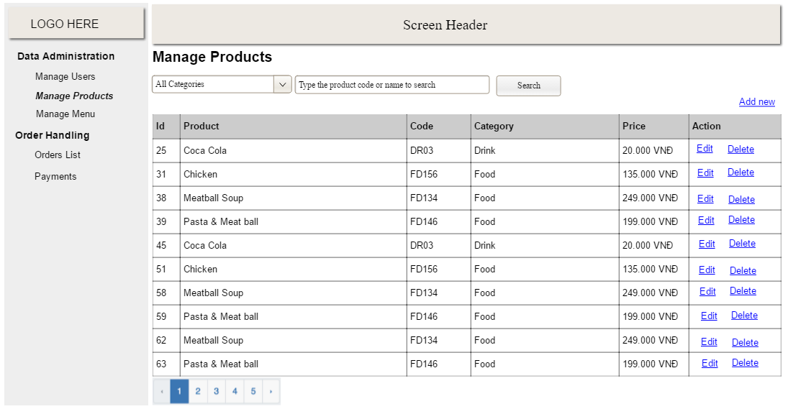

* *Function Details: provide explanation for the data, validation, business logics, functionalities (for both normal cases and abnormal cases), etc. of the function so that the reader can image how it work.*

*]*

### b. <<Function Name 2>>

…

## 2. <<Feature Name 2>>

…